Kindergarten  - 1- pair of safety scissors  - 3- boxes of crayons  - 4- glue sticks  - 24 #2 pencils  - 2- dry erase markers  - 3- pink erasers  - 2- Kindergarten primary writing tablets  - 2- plastic 2 prong folders with pongs  - 1 -supply bag with a zipper  - 1 -Writing Journal from Knowledge Tree  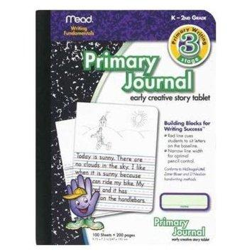  Teacher’s Wish List  Kleenex  Baby wipes | 1st Grade  - 3- boxes Crayola 16 count crayons  - 1- pair of safety scissors  - 2- large or 6 small Elmer’s glue sticks  - 2- large pink erasers  - 1 -pencil pouch  - 2- Writing Journal from Knowledge Tree.  Lines for writing on bottom, space for picture on top.  OR  Send two dollars and we’ll purchase one for you.  - 48 -(wood) (only yellow) pencils  - 4-two pocket folders with prongs  - 1- pack of wide rule notebook paper  - 2- wide ruled compositions notebooks  Teacher’s Wish List  Kleenex  Girls : Gallon Ziploc bags  Boys: Quart Ziploc bags | 2nd Grade  - 5-two pocket folders with prongs  - 2- packs of wide rule notebook paper  - 4- wide rule composition notebooks  - 48 -#2 plain yellow pencils  - 1- box of 24 crayons  - 4 -dry erase markers  - 2- glue sticks  - 2- packs of post it notes  - 1-zipper pencil pouch  - 2- boxes of Kleenex  - 2- packs of pencil top erasers  Teacher’s Wish List  Kleenex  Hand Sanitizer  Girls : Gallon Ziploc bags  Boys: Quart Ziploc bags
3rd Grade  - 2 - packs of #2 pencils  - 3 - packs of wide rule notebook paper  - 1 - box of crayons (24 count)  - 2 - packs of erasers  - 1 - cloth pencil bag  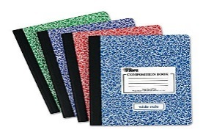  - 4 – wide ruled compositions notebooks (ones with NO wire)  - 4 – small dry erase markers  - 2- boxes of Kleenex  - 2- 3-ring binders | 4th Grade  - 4- wide rule composition notebooks  - 2 -Packs of Notebook Paper  - 4 -folders with prongs and pockets  - 1 inch Clearview binder  - 2- packs of pencils  - 4- small dry erase markers  - 1- Small pencil pouch  - 2- boxes of Kleenex  - 1- pack of Highlighters  - 1- pack of headphones | 5th Grade  - 2 Composition Books- one black, one red  - 2 spirals- one black, one red  - 48 yellow #2 Pencils  - 1 pack of Colored Pencils  - 4 packs wide rule Notebook Paper  - 2 boxes of Kleenex  - 4 small dry eraser markers  - 4 folders with prongs and pockets  - 1- small pencil pouch

